The project focuses on the detection of accidents and analysis of driver behavior using image data captured by onboard cameras or roadside sensors. Accurate detection of accidents and identification of risky driving behaviors are essential for preventing accidents and minimizing their impact on road safety.

Dataset Information:

Link for dataset:

<https://www.kaggle.com/competitions/state-farm-distracted-driver-detection/data>

The dataset comprises a comprehensive collection of images captured from onboard cameras installed in vehicles. These images serve as the primary data source for training and testing our machine learning models. Each image is annotated with information regarding the driving scenario, providing valuable insights into driver behavior and potential accident occurrences.

The dataset is substantial in size, totaling approximately 4.1 GB of image data. This extensive dataset allows for robust model training and evaluation, ensuring comprehensive coverage of various driving scenarios and behaviors.

imgs.zip: A zipped folder containing all the images, both for training and testing purposes.

sample_submission.csv: A sample submission file provided in the correct format for result submissions.

driver_imgs_list.csv: A comprehensive list detailing training images, along with their corresponding subject (driver) ID and class ID, facilitating data organization and management.

Upon downloading the images.zip from dataset extract it in desired folder and make changes of path at the places where training and testing images are being used.

Here is the zip file link containing all the require data:

https://drive.google.com/file/d/15fLngXZUOxxqFQnVh7ngWuVm1ZRWxCB7/view?usp=sharing

## Histogram of Images by Categories

Each category Image count:

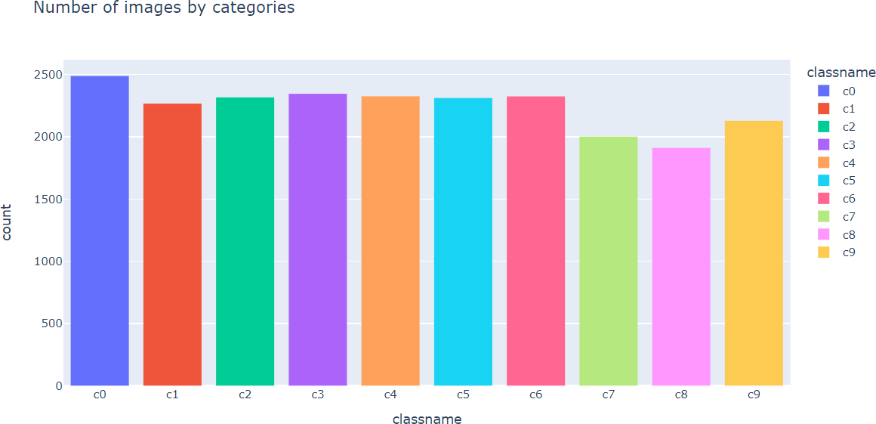

**Frequency of Images per Driver**

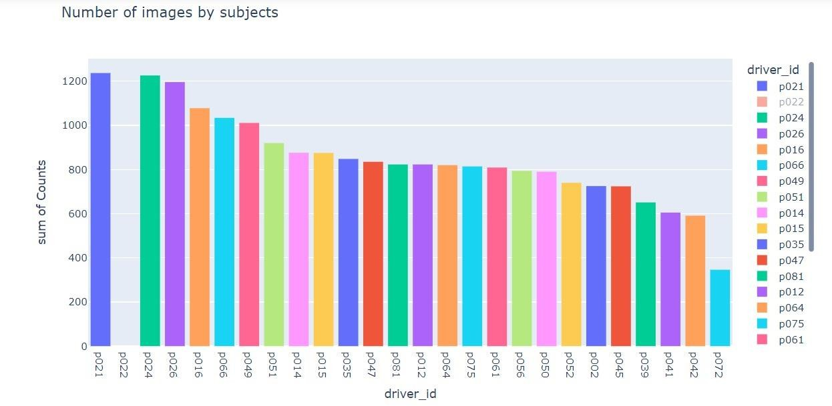

**Distribution of Images across Classes for Each Driver**

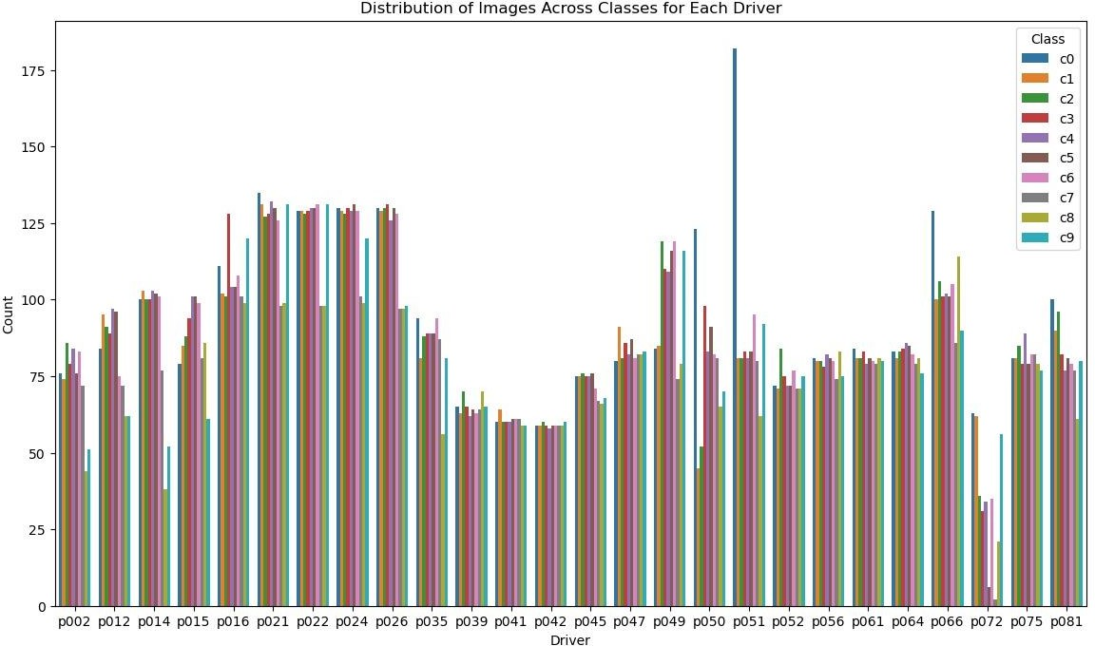

**Sample Images from Each Class**

Safe driving Texting – right Talking on the phone right. Texting – left Talking on the phone left.

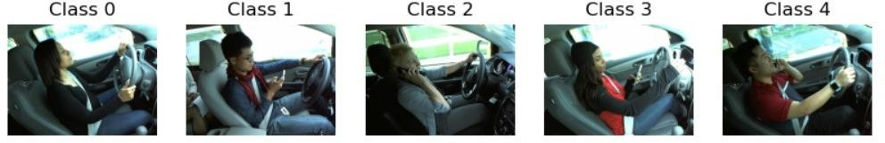

Operating the radio Drinking Reaching behind Hair and makeup Talking to passenger

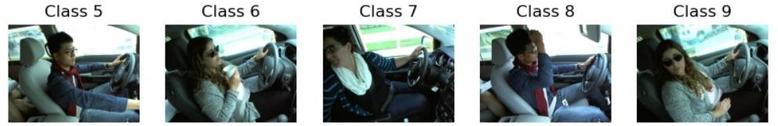

## Prediction Results

Model predictions on test data are analyzed to assess the effectiveness of accident detection and driver behavior analysis.

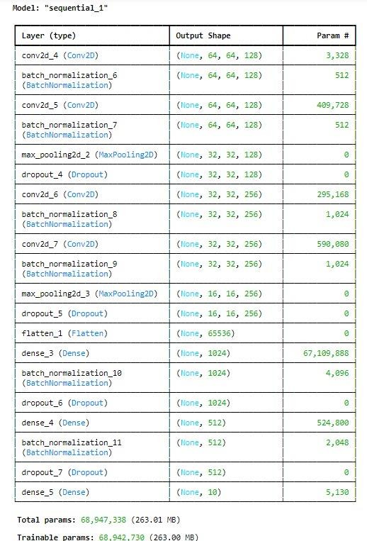

Model Accuracy and loss:

